CS 255 System Design Document Template

UML Diagrams

UML Use Case Diagram
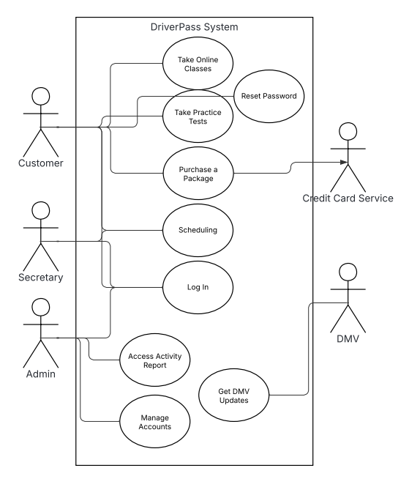

UML Activity Diagrams
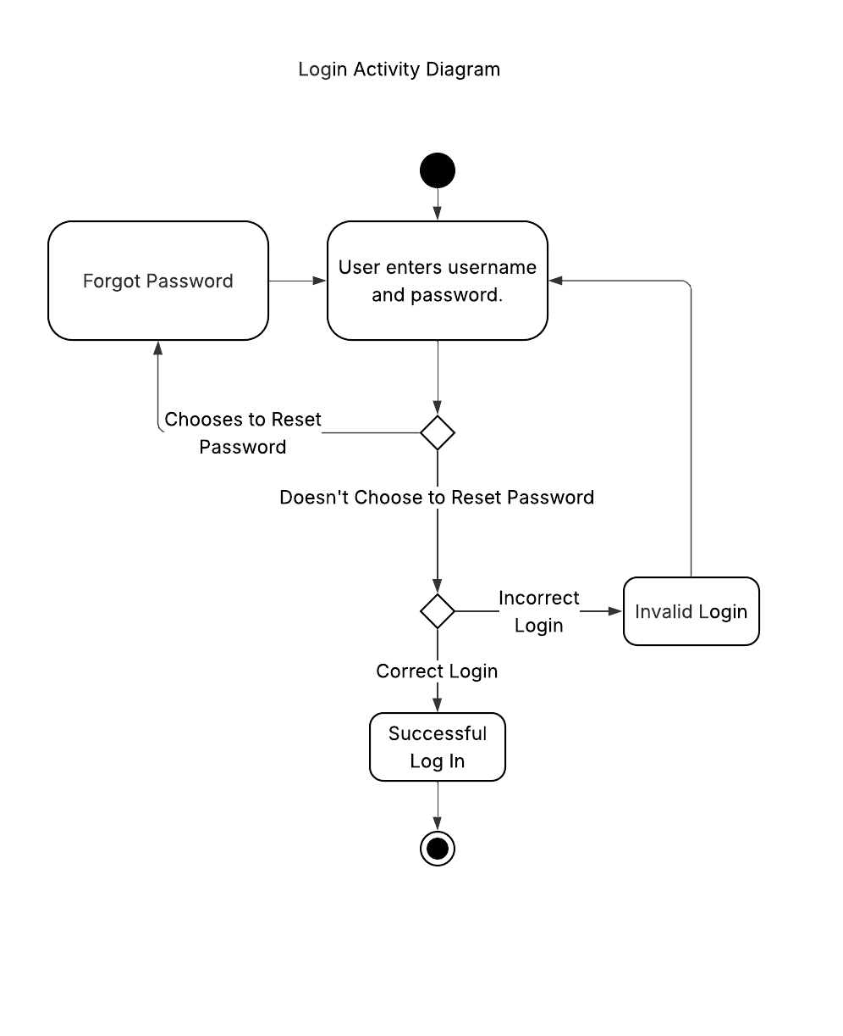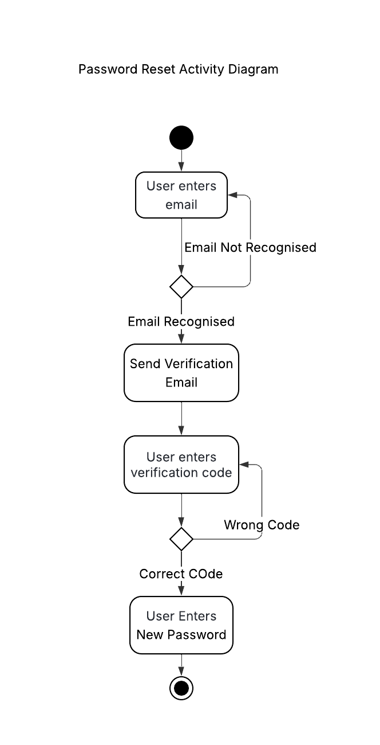

UML Sequence Diagram
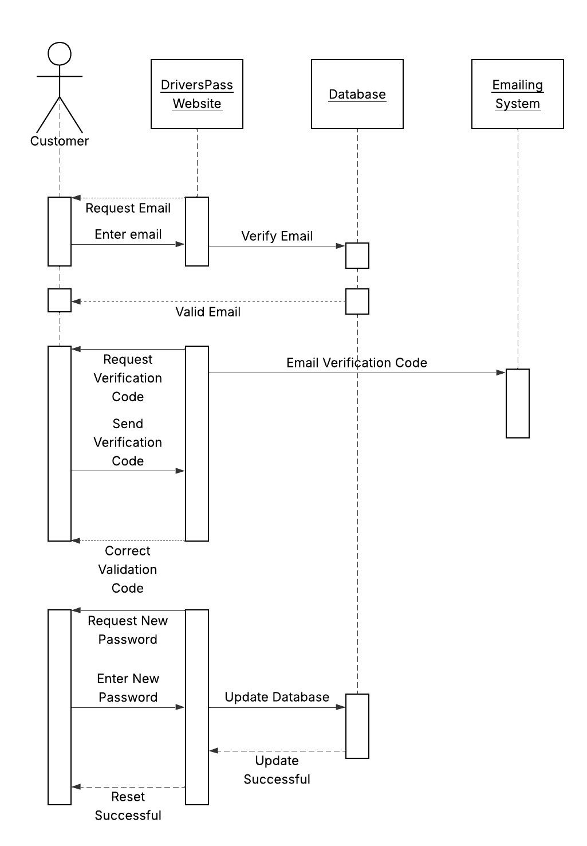

UML Class Diagram
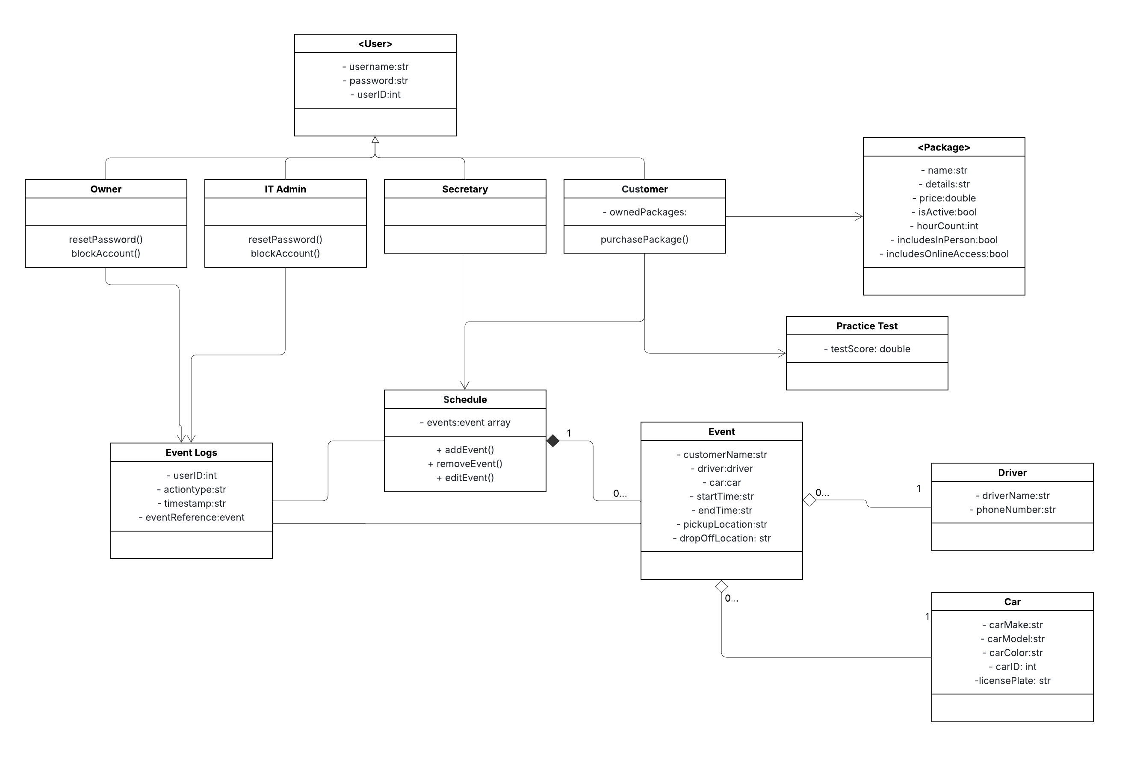

Technical Requirements
The DriverPass system requires a combination of hardware and software components working together with efficient infrastructure in order to support its functionality. On the hardware side, the system will not rely on on-side servers and instead will use cloud-hosting services. Client-side users will need personal devices that are web-capable devices like computers, laptops, or smartphones.
Software-wise, the system will require web app framework to host back-end and front-end access. A database will be required to store persistent data represented in the diagram, like user accounts, events, schedules, and access logs.
The infrastructure must support HTTPS encryption for all data transfers because the personal data should be securely stored in the system. The cloud platform has to have automated backups as specified by Ian. Last, the database must support concurrent access across multiple users.

